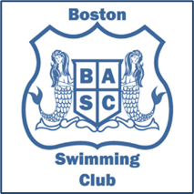BOSTON AMATEUR SWIMMING CLUB KIT LIST 2023

Sharks Lvl 1  Sharks Lvl 2 | Juniors | Development Tier 1  Development Tier 2 | Performance
Kick board  Pull buoy  Mesh bag | Snorkel  Long Training Fins  Watch for recording times  Kick board  Pull buoy  Mesh bag | Snorkel  Hand paddles (optional)  Long Training Fins  Watch for recording times  Kick board  Pull buoy  Mesh bag | Snorkel  Hand paddles  Skipping rope  Long Training Fins  Watch for recording times  Kick board  Pull buoy  Mesh bag

All squads: Water bottle and goggles. Girls: one piece swimsuit (no bikinis), swim cap. Boys: swim trunks/jammers – swim cap compulsory depending on hair length.
Club hats must be purchased via the Swimming Club and worn at all competitions. Club Tops are also required for all competitions and fixtures.

